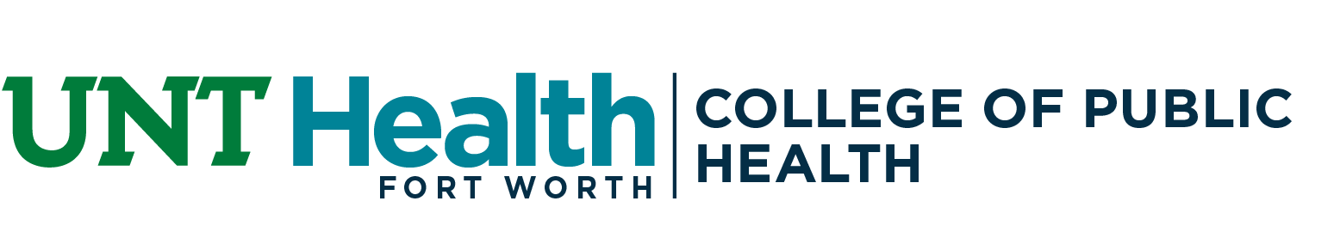

PhD Program Roadmap & Progress
Student: _______________________________________
Primary Advisor: _______________________________________
Other Mentor(s) or Committee Members: ___________________
Semester/Year: _______________________________________

This form should be updated at the start of the Fall and Spring Semesters by the student and primary advisor. The form is expected to be iterative; you only need to adjust and add as needed. Submit the signed form along with the student’s current CV to the MS/PhD Program Director by the second week of the Fall and Spring Semesters. Information from this form will be used alongside faculty input to evaluate student progress each year.

1. Mentorship & Communication Plan
Meeting Frequency: Weekly Biweekly Monthly Other: ________
Preferred Format: In-person Zoom
Who initiates meetings? Student Advisor Both

2. Time Allocation
Research (hrs/wk): ______________ (Primary Advisor)
Research (hrs/wk): __________________ (Secondary/Other Advisor)
Teaching/TA (hrs/wk): ________________
* Total hrs/wk should sum to 20 if receiving stipend

3. Research Engagement & Professional Development
This semester, the student will participate in the following activities:
Student Journal Club
Emerging Leaders Forum
Research ethics or RCR training
Grant/proposal writing workshops
Writing retreats or productivity groups
Faculty candidate job talks or other UNT Health research talks
Other: _________________________

4. Academic Progress
Use this table to plan and track major academic and career milestones.
Milestone | Planned Term | Actual Term | Notes
Finalize degree plan |  |  | (typically upon admission)
Complete all required courses
Form comprehensive exam committee
Pass comprehensive exam
Identify dissertation topic
Form dissertation committee
Dissertation proposal
Dissertation defense
Gain teaching experience
Engage in service/leadership
Develop a personal statement for academic positions
Write & submit external grant/fellowship applications (e.g., NIH F31, NSF, etc.)
Complete mock job talk or research presentation (for job prep)

5. Publication & Writing Progress
List planned or published manuscripts (both first- and co-authored).
Tentative Title | Role (e.g., 1st author, co-author) | Type of Manuscript (e.g., empirical, review, methods) | Target/Submission Date | Status (e.g., drafting, submitted, published)

6. Conferences & Presentations
List planned or presented presentations. Include conferences, internal symposia & research days.
Conference/Symposia Name | Presentation Type (Oral, Poster, Panel) | Target/Submission Date | Status

7. Self-Assessment & Career Interests
Strengths: ___________________________________________
Areas for Development: _________________________________
Primary Career Goal (e.g., faculty at university, research institutes, state or federal government, industry position): ___________________________________
Alternate Career Interests (if any): ____________________________
Have your goals changed since last semester? Yes ☐ No ☐ If yes, explain: ____________________________
Resources or Support Needed (e.g., grant writing workshop, teaching practice): ____________________________

8. Skills & Professional Development Plan
Identify 2–3 skills you need for your intended career path and how you will build them.
Skill/Competency (e.g., qualitative, AI, coding, communication, leadership) | Planned Activities (e.g., Course, Experience) | Timeline

9. Additional Expectations & Notes
___________________________________

Student Signature: ____________________________________________ Date: ___________
Faculty Advisor Signature: ___________________________________ Date: ___________

