How to Access the CoreStream Platform
- Open Your Web Browser
Launch your preferred web browser (e.g., Chrome, Firefox, Safari).
- Visit the CoreStream Platform URL
In the address bar, type or paste the following URL:
https://unthsc.corestreamplatform.com/
Press Enter.
- Access the Authentication Page
You will be directed to the authentication page.
- Log in Using Single Sign-On (See Image below)
  - Click on the ‘UNTHSC Users Single Sign On’ button.
  - This will prompt you to authenticate using your organization’s credentials.
- Complete Your Organization Authentication
  - Enter your username and password as required.
  - Follow any additional authentication steps as prompted.
- Access the Home Page
Once authentication is successful, you will be logged into the Home page of the CoreStream platform.
- Navigate to 'My Disclosures' (See image below)
  - Look for the 'My Disclosures' tile on the Home page.
  - Click on the 'Launch' button associated with this tile.
- View Your Personal 'My Disclosures' Grid
You will now be taken to your personal 'My Disclosures' grid, where you can see any outstanding disclosures that require your input.

4.
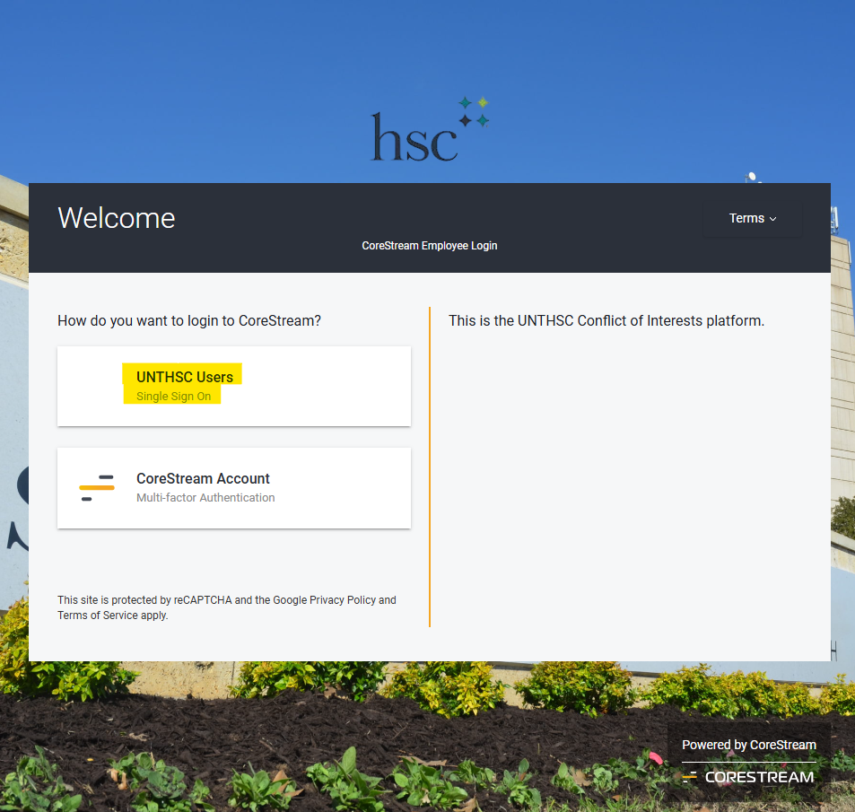

7.
