SMART GOALS
(See Appendix for detailed instructions on using this template)

Investigator: Type contact PI's name in this box.

REAP Intramural Funding RFA:

* Topic Area (Research Special Interest Award Only):

SMART Goals, Term 1: Progress milestones for months 0-6

*SMART Goal 1 (required):
Category:
Statement of Goal: | Enter your SMART goal statement here (see Appendix at end of this document for guidance). The text box will expand as you type.
Indicators of Success: | What measurables will indicate if you have successfully made progress towards this goal? The text box will expand as you type.
Potential Setbacks: | Describe potential issues that may affect your ability to accomplish this goal and how you will respond. If no setbacks are foreseen, please state "NA". The text box will expand as you type.

SMART Goal 2 (if applicable):
Category:

Statement of Goal: | Enter your SMART goal statement here (see Appendix at end of this document for guidance). The text box will expand as you type.
Indicators of Success: | What measurables will indicate if you have successfully made progress towards this goal? The text box will expand as you type.
Potential Setbacks: | Describe potential issues that may affect your ability to accomplish this goal and how you will respond. If no setbacks are foreseen, please state "NA". The text box will expand as you type.

SMART Goal 3 (if applicable):
Category:

Statement of Goal: | Enter your SMART goal statement here (see Appendix at end of this document for guidance). The text box will expand as you type.
Indicators of Success: | What measurables will indicate if you have successfully made progress towards this goal? The text box will expand as you type.
Potential Setbacks: | Describe potential issues that may affect your ability to accomplish this goal and how you will respond. If no setbacks are foreseen, please state "NA". The text box will expand as you type.

SMART Goals, Term 2- Progress milestones for months 6-12

**SMART Goal 1 (required):
Category:
Statement of Goal: | Enter your SMART goal statement here (see Appendix at end of this document for guidance). The text box will expand as you type.
Indicators of Success: | What measurables will indicate if you have successfully made progress towards this goal? The text box will expand as you type.
Potential Setbacks: | Describe potential issues that may affect your ability to accomplish this goal and how you will respond. If no setbacks are foreseen, please state "NA". The text box will expand as you type.

SMART Goal 2 (if applicable):
Category:

Statement of Goal: | Enter your SMART goal statement here (see Appendix at end of this document for guidance). The text box will expand as you type.
Indicators of Success: | What measurables will indicate if you have successfully made progress towards this goal? The text box will expand as you type.
Potential Setbacks: | Describe potential issues that may affect your ability to accomplish this goal and how you will respond. If no setbacks are foreseen, please state "NA". The text box will expand as you type.

SMART Goal 3 (if applicable):
Category:

Statement of Goal: | Enter your SMART goal statement here (see Appendix at end of this document for guidance). The text box will expand as you type.
Indicators of Success: | What measurables will indicate if you have successfully made progress towards this goal? The text box will expand as you type.
Potential Setbacks: | Describe potential issues that may affect your ability to accomplish this goal and how you will respond. If no setbacks are foreseen, please state "NA". The text box will expand as you type.

APPENDIX: WRITING YOUR SMART GOALS

Overview of Requirements. SMART goals are intended to measure project progress, not outcomes. A REAP representative will meet with the PI(s) at two intervals (6 months and 12 months) to determine progress towards SMART goals. SMART goals may address any of the following categories:

- Project logistics (e.g., getting approval of an IRB)
- Research progress (e.g., protocol implementation, data generation/collection)
- Dissemination (e.g., writing manuscript, presenting at a conference)
- Future funding acquisition (e.g., drafting specific aims page, submitting grant).

Up to three (3) SMART goals can be specified per reporting period; at least one (1) SMART goal is required per reporting period. Please note that these goals should represent a holistic view of the project’s progress.

Guidance. Please see the following examples and resources to help you write your SMART goals. Each SMART goal will have the following elements: Category (see prior section for definitions), Statement of Goal, Indicators of Success, and Potential Setbacks (if applicable).
- Phrasing a SMART goal statement:
  - (SOMEONE) will (ACCOMPLISH AN OBJECTIVE) by (TIME) for the purpose of (RESULTS).

- Examples of well-written SMART goal statements:
  - By October 15, 2026, I will have a draft of my specific aims page ready for feedback from my colleagues to ensure it is ready for submission by January 31, 2026.
  - In June 2026, my team will present the findings of this work at the AAIC conference to gain visibility and bolster our team’s presence in the field of Alzheimer’s Disease.
  - By the end of FY26, we will have a protype of the device ready for testing, and testing team members will confirm that it is more user-friendly.
- Example of completed SMART goal table:

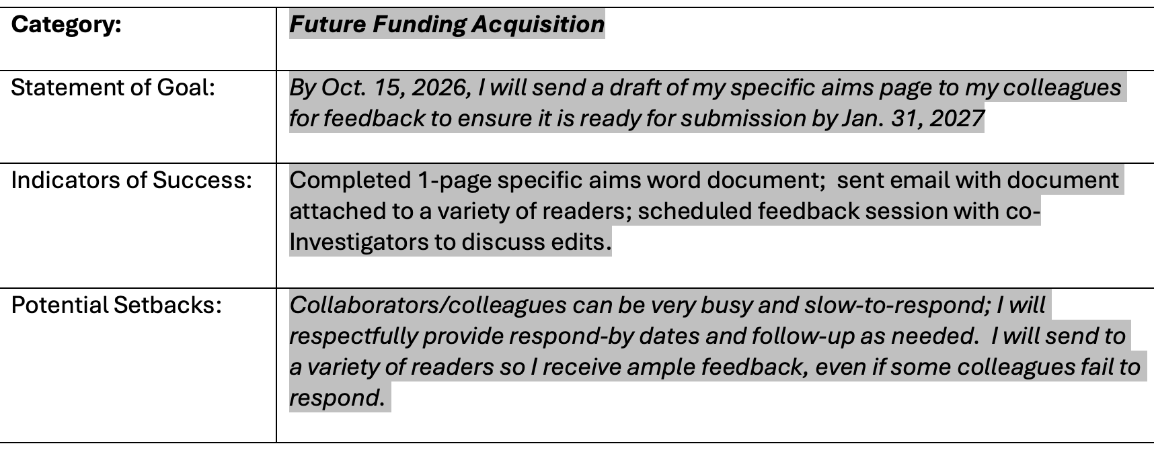

Additional Resources. There are many great resources on the web; here are a few within the UNT System materials.

- UNT System Resource:
  - https://studentaffairs.unt.edu/student-activities-center/programs-and-services/student-organizations/officers/org_smart_goal_setting.pdf
- UNT Health resource, with link Mindspace page with some additional information:
  - https://www.unthsc.edu/care-and-civility/wp-content/uploads/sites/48/How-to-Set-SMART-Goals.pdf

